Lesson plan – using completing the square to sketch graphs – consolidation and assessment
We have been learnt to complete the square for quadratic expressions (revision here) and how to determine the turning point for an expression in completed square form (revision and practice here)
We are now going to put it all together – use what we know about how to complete the square and deduce the turning points on a graph, and then sketch the graphs. Here is a demonstration of some simple (coefficient of $x^{2}$ is 1) quadratic expressions using Geogebra. Unclick all the boxes and try to sketch the graphs yourself, then check by clicking the boxes. You can change the coefficients of x and the constant by using the sliders b and c
Example: Practising without answers
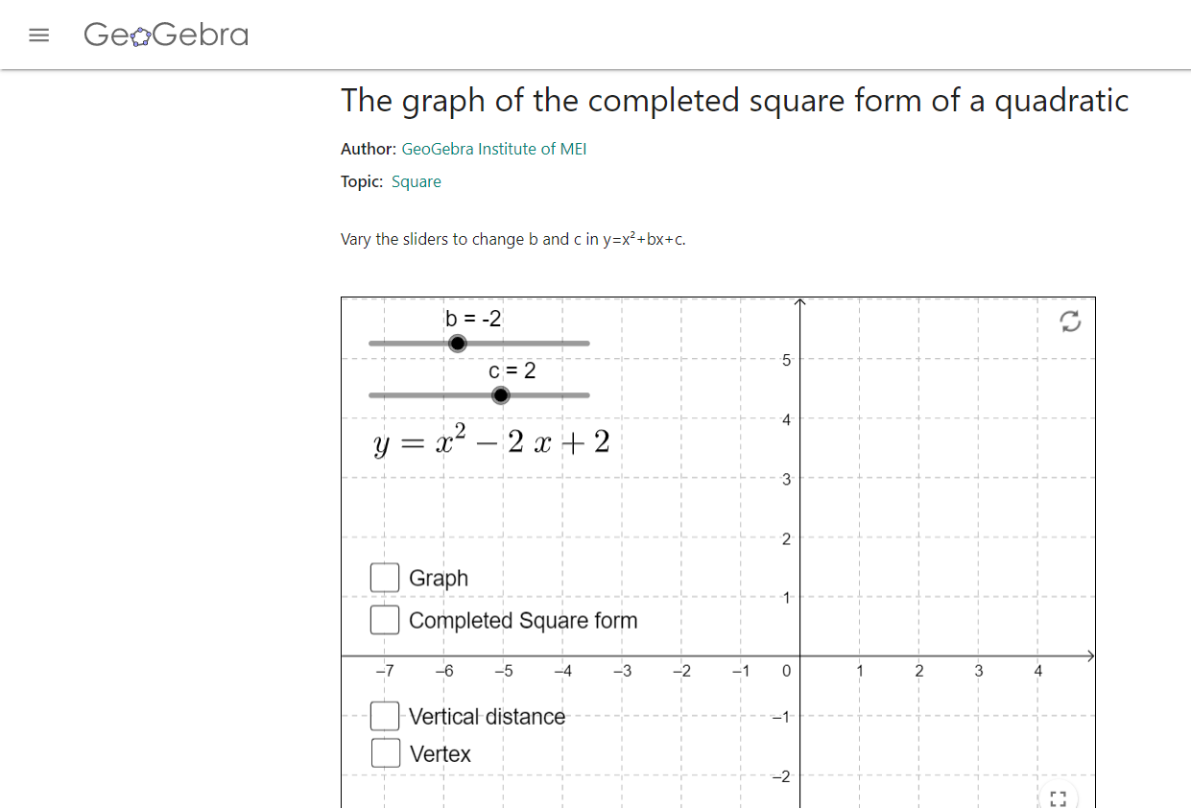
Then click on boxes to get answers
Why I like this
- Fun
- Interactive
- Many examples
- Provides visual demonstration of how changing coefficients and constants changes position of graphs
Online interactive testing
I would like you to log onto Integral and complete the unit test on quadratic functions
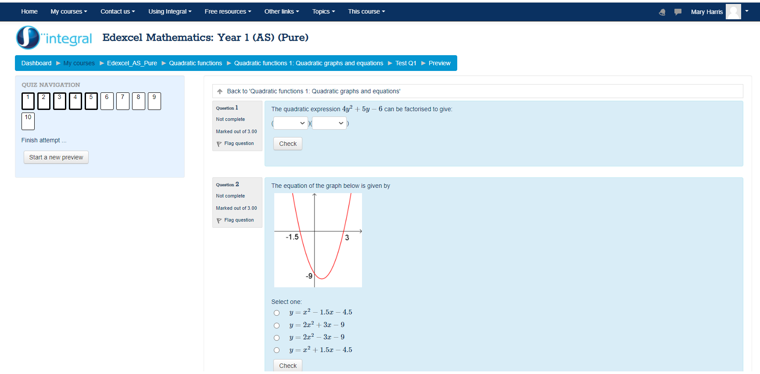

Why I like this?
- Interesting, mixed and challenging questions
- Instant feedback for students
- Teacher sees results at any point by looking at group
- Student can have second chance for each question

Worksheet to hand in.
Please print off the worksheet here. Complete it as per the example and either scan and return to hand in. For the brave who would like to try equation editor in Word (as per my example), have a go at completing without printing! [Note you will need to have equation editor set up in your version of word)]. Remember to show the y intercept on each graph (set x = 0 in the original equation).
Why I like this
- Includes progression – form simple positive quadratics with coefficient of x^2 being 1 and integers in completed square form, to negative quadratics with coefficients other than 1 and fractions in completed square form

- Easy to mark and assess – one sheet with all formats the same

- Provides example so can understand required answer.

- Can be printed double sided to one sheet.

- Students can download, complete, scan and return (all have downloaded scanning app) or alternatively – some try their hand at equation editor in word as I have in the example.

Caution when using hyperlinks on this document. For all web-based hyperlinks there is no problem as address is common to all users. When using documents stored in an area (eg final worksheet), this will need to be downloaded and stored in area students can access. For Integral link, must ensure students have been set up.

